ORGANIZATION ANNOUNCEMENT HUB
@CREATIVITY THINK (9483175986/7019689991)

ABSTRACT:
Organization Announcement Hub is a web-based platform designed to streamline the creation, distribution, and tracking of announcements within companies, societies, and schools. The system allows administrators to publish announcements, moderate feedback, and monitor engagement through analytics dashboards. Users can receive notifications, provide feedback, and view interactive dashboards. Developed using Django and Django Rest Framework for backend processing, and React with redux and recharts for frontend interactions, the platform provides secure communication, organized management, and actionable insights, enhancing internal communication efficiency..

INTRODUCTION OF THE PROJECT:
Organizations often struggle to communicate updates effectively across teams or members, leading to missed information and poor engagement. Existing methods, such as emails or group chats, do not provide structured tracking or feedback mechanisms. The Organization Announcement Hub addresses these gaps by providing a centralized platform where administrators can publish announcements, moderate responses, and view engagement analytics. Users receive announcements, provide feedback, and monitor relevant statistics in real time. This system improves internal communication, ensures accountability, and promotes active participation within the organization..

PROJECT OBJECTIVES:

• Provide a centralized platform for posting and receiving announcements
• Allow users to provide feedback on announcements
• Track engagement and responses through dashboards
• Enable administrators to moderate feedback and comments
• Offer analytics for understanding user interaction
• Ensure secure and reliable communication within the organization
• Facilitate efficient internal communication workflows
• Support structured reporting for decision-making

PROBLEM OF THE STATEMENT:
Traditional methods of announcements, such as emails or notice boards, lack real-time tracking, structured feedback, and analytics. This often leads to missed information, low engagement, and ineffective communication. Administrators have no centralized view of responses or user engagement, making it difficult to measure impact. Organization Announcement Hub solves these problems by providing a platform that combines secure announcements, user feedback collection, moderation capabilities, and comprehensive analytics, ensuring effective communication and accountability..

MOTIVATION OF THE PROJECT:
• To centralize the announcement workflow within organizations
• To provide real-time feedback and engagement tracking
• To improve communication efficiency and participation
• To offer administrators a structured dashboard for monitoring responses
• To facilitate moderation of inappropriate comments or feedback
• To ensure transparency and accountability in information dissemination
• To enhance organizational collaboration and member interaction

BLOCK DAIGRAM OF PROJECT:

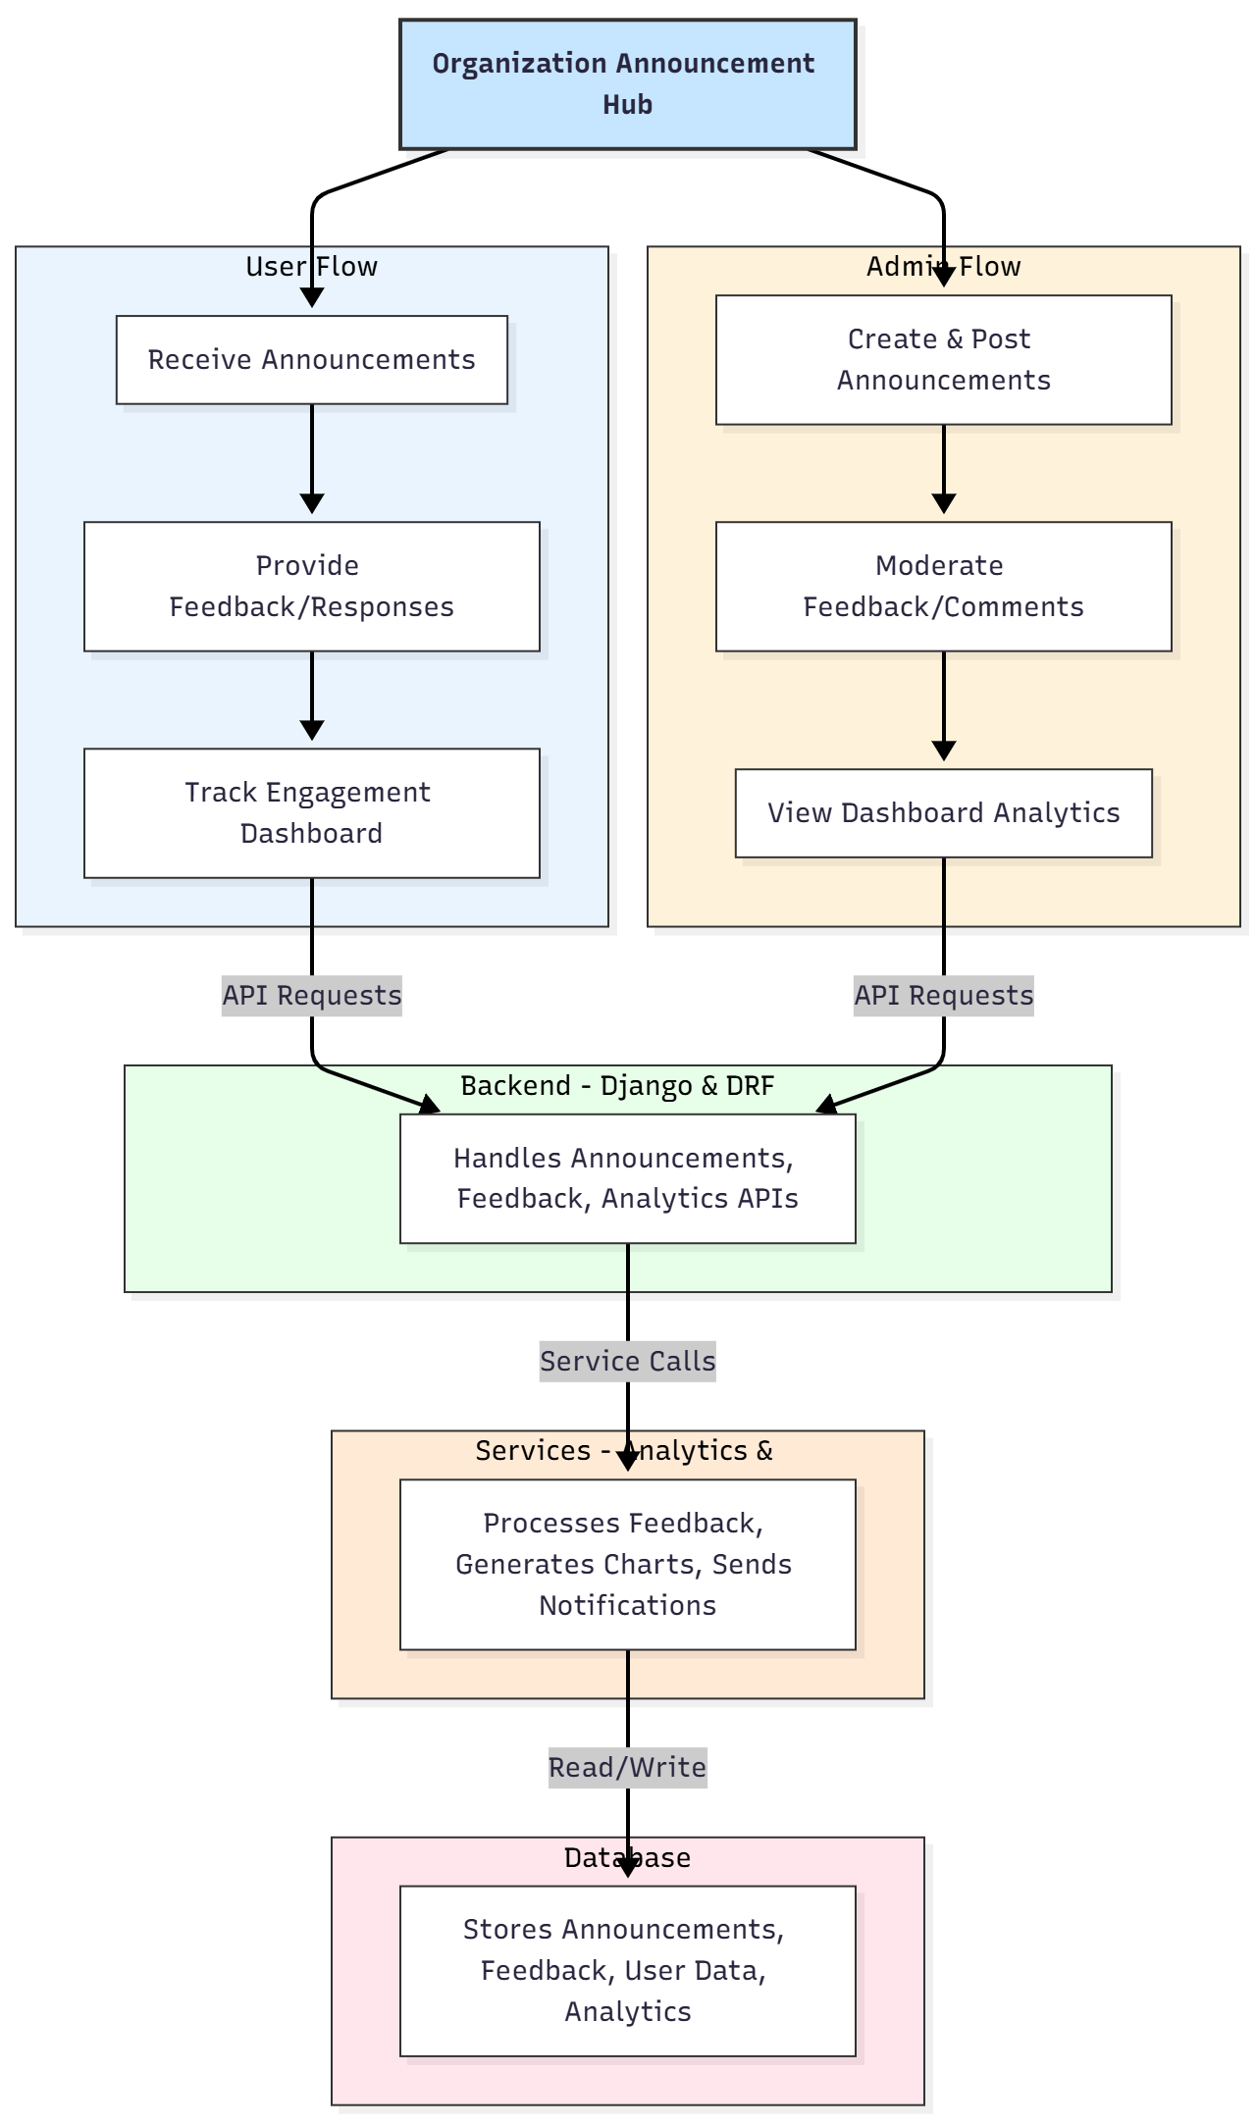

WORKING OF THE PROJECT:
Administrators create and post announcements through a secure backend interface. Once posted, users receive notifications and can respond with feedback or comments. The system logs all interactions and updates dashboards to reflect engagement metrics such as response rates and user activity. Administrators can moderate feedback to ensure appropriate content and generate analytics reports using charts and visual tools. The services module handles notifications and analytics processing, while the database stores announcements, user responses, and dashboard data, providing real-time insights for decision-making and communication improvements..

SOFTWARE REQUIREMENT:
- Backend:
  - Python 3.x
  - Django
  - Django REST Framework
  - SQLite/PostgreSQL
- Frontend:
  - Node.js and npm
  - React.js
  - Axios
- Development Tools:
  - Visual Studio Code
  - Postman (for testing APIs)
  - Git/GitHub (for version control)
- Server/Deployment (Optional):
  - Gunicorn, Nginx, or Heroku/AWS for hosting

ADVANTAGES OF THE PROJECT:

• Centralized management of announcements
• Real-time tracking of feedback and engagement
• Moderation of inappropriate comments
• Visual analytics dashboards for admins
• Transparent communication within organizations
• Efficient internal communication workflow
• Reduces dependency on email or physical notice boards
• Enhances participation and organizational collaboration

APPLICATIONS OF THE PROJECT:
• Companies and corporate offices
• Residential societies
• Schools and educational institutions
• Clubs and associations
• Non-profit organizations
• Any organization requiring structured communication

REFERENCES:

- Django REST Framework Documentation — Django Software Foundation. Django Documentation. Available: https://docs.djangoproject.com/
- Django REST Framework. DRF Documentation. Available: https://www.django-rest-framework.org/
- React. React Official Documentation. Available: https://reactjs.org/docs/getting-started.html
- Redux. Redux Documentation. Available: https://redux.js.org/introduction/getting-started
- PostgreSQL Global Development Group. PostgreSQL Documentation. Available: https://www.postgresql.org/docs/
- MySQL. MySQL Reference Manual. Available: https://dev.mysql.com/doc/
- Git. Git Documentation. Available: https://git-scm.com/doc
- Node.js. Node.js Documentation. Available: https://nodejs.org/en/docs/
- Axios. Axios Documentation. Available: https://axios-http.com/docs/intro
- Socket.io Documentation – https://socket.io/docs/

